Assessment 1-Using Secondary Data: A Virtual Fieldtrip to Cappadocia

Deniz Ismailoff
New Jersey City University
EDTC 803: Data Analysis and Report Writing
Dr. Tracy Amerman
July 29, 2020

Using Secondary Data: A Virtual Fieldtrip to Cappadocia

Sound Design Principles and Purpose

Working in the education field in urban districts for over 13 years, I recognize the diversity of learning styles amongst students. As a leader, my vision is to see students venture forth in life after school with real wisdom and individual purpose for making a positive difference in the world ahead. I also believe that providing a variety of strategies, methods, and models makes learning accessible and exciting for all levels of learning. Virtual field trips are one way that we can enhance our students' learning development. Particularly, virtual field trips are changing the way elementary school students explore the world. Educators are currently incorporating virtual field trips into their classrooms to supplement live field trips, increase the frequency and variety of student excursions, or altogether replace the inaccessible or expensive field trips. Virtual field trips instantly connect students with learning opportunities they may not get to experience otherwise in the comfort of their environment.
There are numerous benefits of taking a virtual field trip compared to a traditional field trip. Delacruz (2019) explains that some field trip sites are unsafe, not practical, or economically possible. For instance, liability and safety concerns may arise if a teacher wants to take a class trip to a site such as the city of Cappadocia in Turkey. However, it could be more feasible if done as a virtual field trip. If a classroom were studying the history, mythology, region, and museums of Cappadocia, a field trip to this beautiful city would enlighten the students' experience. However, it may not be economically possible or safe due to the Covid-19 pandemic to visit Cappadocia, therefore taking a virtual field trip of this site would be informative and engaging. Although virtual field trips are accessible for all grade levels, “there are a few empirical studies of their impacts on student outcomes” (Adeokun et al., 2015 p.91). However, recent studies indicate that including STEM education into cross-curriculum studies advances student knowledge through best teaching practices and programs. Federal funding agencies, including the National Science Foundation and the Institutes for Education Sciences, have called on STEM education evaluators to go beyond traditional teaching methods and consider using more rigorous and engaging methods of teaching (Niemitz et al., 2008). Thus, as our students are evolving in a global society, they must understand how science, technology, and history can interconnect to understand both their own culture and the culture of their peers.
Educational Objective, Experience, and Rationale
Students can utilize technology to explore cultures and environments that they have not traveled to before. Fortunately, the internet has enabled students to participate in cross-cultural online learning opportunities with popular platforms such as Skype or Google Hangouts. Networks such as the International Education and Research Network (iEARN), Skype in the Classroom (https://education.microsoft.com/skypeintheclassroom), the Global SchoolNet (worldwide e-projects and online expeditions), and The Wonderment (Project paths from around the world) are great resources for teachers to find classrooms around the globe with which to connect (Adeokun et al., 2015). Educators should consider the platform utilized for conducting cross-cultural online activities. "A good platform needs to be user friendly regardless of students' cultural background, low-cost for all participants, easy to manage and maintain from the standpoints of both instructors and students, and fulfill the needs of the teaching and learning requirements" (Wang [37], p. 63).
The educational objective for this unit of study will allow fifth-grade students to understand the history, mythology, region, and museums by reading and visiting the beautiful sites of Cappadocia. Students will have a website, an interactive PowerPoint presentation, GoogleMap’s 360 Images, Google Expeditions to get up close with the historical landmarks of Cappadocia, and a Virtual Reality app to explore and embrace the underground cities, regions, monasteries, and museums.
The Virtual Reality experience will differ each time it is explored since the students can focus their attention on any part of the 360-degree video. Before starting the Virtual Reality field trip, students will watch provided tutorials on how to utilize the goggles, platform, and 360-degree pictures (“ClassVR Setup”, 2019). Multiple viewings and utilizing a headset will help students explore the content in an innovative way and notice more details with each visit to Cappadocia. Students will be able to think critically and logically about the history and cities and compare them with real-life conditions. They will also formulate scientific explanations, such as the formation of rocks that shaped into cities, and utilize the appropriate tools, such as the provided technology resources to gather, analyze, and interpret their experiences through the historical landmarks of Cappadocia.
Description of Features and Feasibility
For this particular virtual field trip, students will be utilizing chromebooks, an interactive smartboard, and experience a Discovery Virtual Reality tour through Cappadocia's underground cities. The GoogleMap’s 360-degree images of the museums', landforms, and expeditions will allow students to understand the history behind the beautiful renown city. Significant consideration has been put in place with curriculum and planning. Since the reopening plan for my school building in September is to run a hybrid model, where students are assigned two days a week with a rotating schedule for Fridays, our virtual field trip will take place from home and school. The hybrid model will permit class sizes of 20 to be split in half (10 students will learn remotely through live streaming from home and 10 students in school wearing face masks), allowing schools to follow social distancing regulations. Plexiglass will also be in place for every desk to help provide a safe and versatile learning environment. Live streaming lessons will be implemented, where students are expected to log on to view and participate on the days they are at home. This hybrid, live streaming model will allow for the necessary home-school connection.
The students in class will be utilizing their own chromebooks, the classroom interactive smartboard (which are both already provided by the school), and the Discovery Virtual Reality goggles. The students who will be at home during these days will be provided with chromebooks in order to live stream and complete the expeditions online. Figure 1 shows a visual representation of the students’ learning environment in school and at home. Once students rotate schedules, the activities will differ based on the technology in class and at home. Hand sanitizers will be utilized after each interactive smartboard usage. A total of 10 goggles will be provided and wiped with antibacterial sanitizing wipes after each use. Since my school building has the majority of technology components for this unit of study, the only extra cost would be to purchase the Virtual Reality goggles. The campus has a set budget based on our needs assessment; books, technology, and manipulates, will be funded. The cost for one set of eight virtual reality goggles costs approximately $2000 depending on the make and model (eBay, 2020). If three sets of goggles are ordered, two classes from the same grade level completing the unit of study can split the sets and save money for additional needs. Thus, this virtual field trip will be informative, engaging, budget-friendly, and allow students to discover new contexts in a safe and authentic environment.

Visual Model

Figure 1
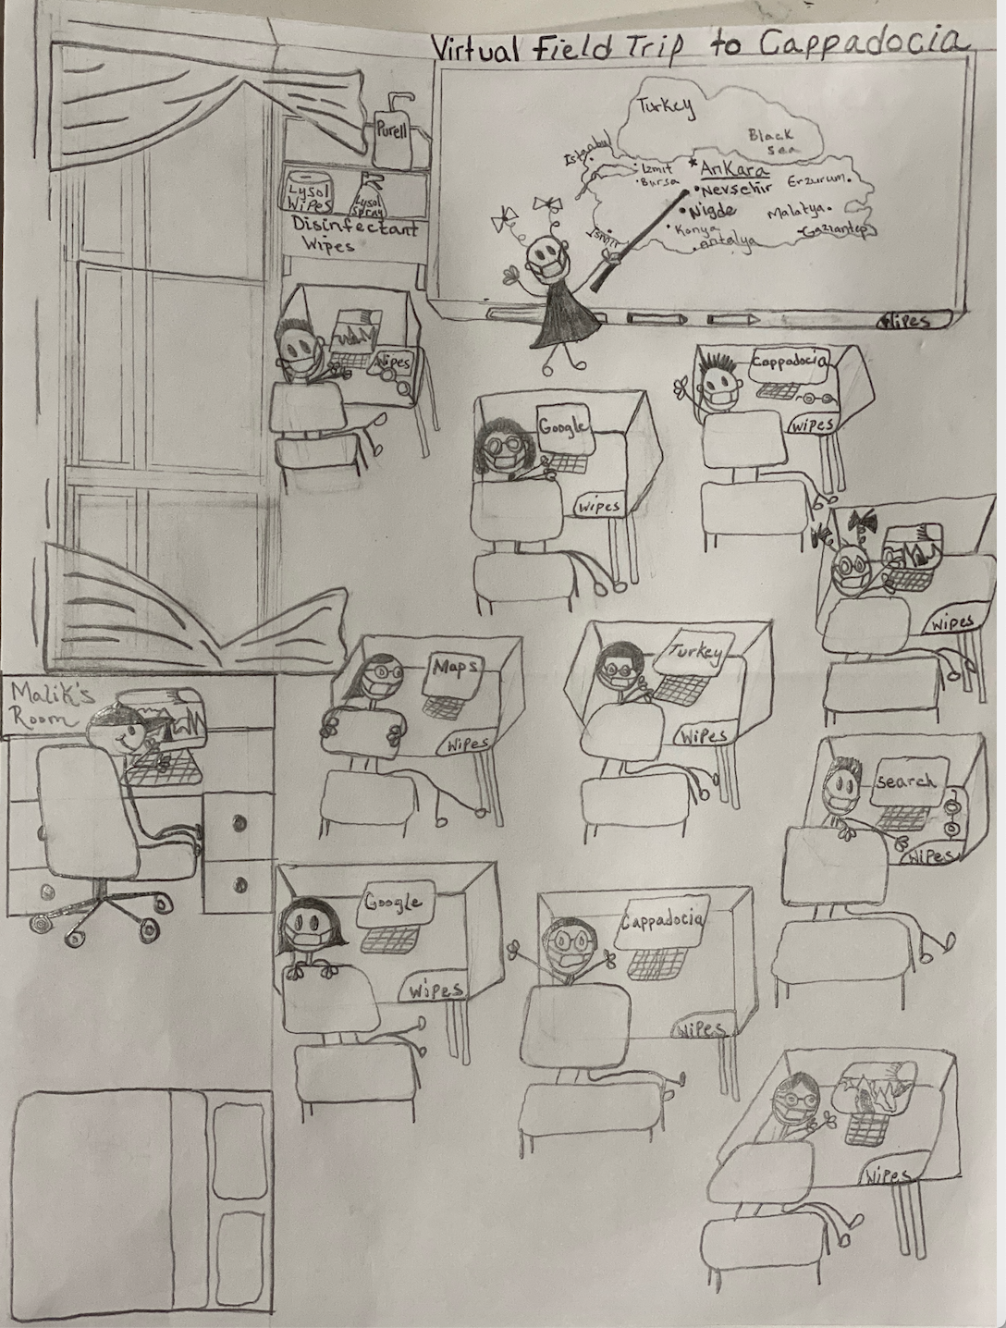
Photograph of Virtual Fieldtrip to Cappadocia Proposal Sketch
Note. Sketch depicts 10 students sitting six feet apart in a classroom. Bottom left sketch depicts one student live streaming the classroom and working remotely from home.

References

Adedokun, O. A., Liu, J., Parker, L. C., & Burgess, W. (2015). Meta-Analytic evaluation of a virtual field trip to connect middle school students with university scientists. Journal of Science Education and Technology, 24(1), 91–102.
Avantis ClassVR with (8) CVR-155-A Standalone headsets & rugged charging case. (2020). eBay. https://www.ebay.com/itm/Avantis-ClassVR-with-8-CVR-155-A-Standalone-Headsets-Rugged-Charging-Case-/352942783413.

Berger, A. (2012, May 1). A video tour of Cappadocia Turkey’s underground city. Virtual way: Travel. https://virtualwayfarer.com/a-video-tour-of-cappadocia-turkeys-underground-city/.
ClassVR Setup and User Guide. (2019). https://support.classvr.com/portal/api/kbArticles/218739000037594097/locale/en/attachments/20e1v7d3969ff2d0b44a68dde6b64969f3e27/content?portalId=edbsnd3ac3c0d9af38a448048d5db3f0daba6f6b9b1cac7c29bd65f6f39948b8ca5c0.
Delacruz, S. (2019). Building digital literacy bridges: Connecting cultures and promoting global citizenship in elementary classrooms through school-based virtual field trips. TechTrends: Linking research and practice to improve learning, 63(4), 428–439.
Mahady, K. (2015). A virtual field trip to Turkey. Math/Science Magnet School. Tucson, Arizona. https://cmes.arizona.edu/sites/cmes.arizona.edu/files/3.%20Virtual%20Field%20Trip%20to%20Turkey.pdf
Niemitz M, Slough S, Peart L, Klaus AD, Leckie RM, St. John K. (2008). Interactive virtual expeditions as a learning tool: The school of rock expedition case study. J Educ MultimedHypermed 17(4), 561–580.
Stoddard, J. (2009). Toward a virtual field trip model for the social studies. Contemporary Issues in Technology and Teacher Education 9(4), 412–438.
Wang C. (2012). Using Facebook for cross-cultural collaboration: The experience of students from Taiwan. Educational Media International. 2012; 49(1), 63-76. https://doi.org/10.1080/09523987.2012.662625.

