**Project 1: Mindfulness and Social-Emotional Learning in Education During Covid-19**

Deniz Ismailoff

New Jersey City University

EDTC 806: Research Methods in Educational Technology Leadership

Dr. Christopher D. Carnahan

March 15, 2021

**Table of Contents**

Chapter I: Introduction……………………………………………………………………..3

Introduction………………………………………………………………………...3

Statement of the Problem…………………………………………………………..4

Purpose……………………………………………………………………………..4

Research Questions………………………………………………………………...4

Chapter II: Review of the Literature…………………………………………………….....6

Introduction...............................................................................................................6

The Effects of Covid-19 in Education.......................................................................6

The Impact of Mindfulness and Social-Emotional Learning....................................7

Student Academic Achievement...............................................................................8

Summary...................................................................................................................10

Chapter III: Methodology....................................................................................................11

Introduction..............................................................................................................11

Research Design.......................................................................................................11

Population and Sample.............................................................................................12

Instrument.................................................................................................................12

Procedures................................................................................................................13

References............................................................................................................................14

Appendix: Survey.................................................................................................................16

Mindfulness and Social-Emotional Learning in Education During Covid-19

**Chapter One: Introduction**

**Introduction**

Social and emotional learning (SEL) and mindfulness are an integral part of education and human development. The Aspen Institute National Commission on Social, Emotional, and Academic Development revised what constitutes success in our schools. Scientific evidence demonstrates that social, emotional, and academic development are interconnected in the learning process (Immordino-Yang et al., 2018). Mindfulness practices have also become one of the most critically essential practices followed in education during Covid-19. Mindfulness maintains a moment-by-moment awareness of our thoughts, emotions, bodily sensations, and surrounding environment with openness and curiosity (Browning et al., 2020).

Mindfulness practices also cultivate attention, including self-awareness and self-knowledge of thoughts, feelings, sensations, and how they affect one's actions. It is a promising approach to teaching educators and students self-awareness and self-regulation skills associated with school success and adulthood (Browning et al., 2020). Lastly, mindfulness skills complement social-emotional learning (SEL), as self-awareness and self-management are among the five core skills of SEL identified by the Collaborative for Academic, Social, and Emotional Learning (CASEL) (Browning et al., 2020). Through mindfulness practices and SEL, children and adults acquire and apply the knowledge, skills, and attitudes required to develop mindfulness, healthy identities, manage emotions, show empathy for others, maintain healthy relationships, and achieve personal and practical goals (Ergas, 2019).

**Statement of the Problem**

The United States is currently trying to overcome the effects of COVID-19. Now, the education system struggles with online and hybrid learning and its effect on students' well-being and academics. Many students are also experiencing higher than everyday stress and anxiety due to the change in their routines, online classes, and learning environments. Mindfulness practices and social-emotional learning can be incorporated into the classrooms as a standalone strategy for teachers' benefit or to utilize with students and be integrated into existing school structures and routines. Individual teachers can integrate practices adapted to fit individual students' needs, groups of students or implemented as a schoolwide commitment to well-rounded education focused on the whole child, teacher well-being, and positive school climate (Browning et al., 2020). With the notion of student well-being in mind, mindfulness strategies and SEL can help relieve daily stressors students are experiencing due to Covid-19, which will help students achieve academic achievement.

**Purpose**

This quantitative study aims to describe the relationship between mindfulness and social-emotional learning practices in education during Covid-19 and student academic achievement. The researcher will determine a correlation, if any, between incorporating mindfulness and social-emotional learning practices for remote and hybrid middle school students during Covid-19 and the rise of student academic achievement.

**Research Questions**

Within this study, three research questions were created to analyze the relationship between mindfulness and social-emotional learning practices in education during Covid-19 and student academic achievement.

1. How can mindfulness and social-emotional learning help students cope during Covid-19?
2. How can social-emotional learning aid student achievement during Covid-19?
3. What are the most critical factors of mindfulness practices that influence student well-being and academic achievement during Covid-19?

**Chapter Two: Literature Review**

**Introduction**

Research regarding mindfulness and social-emotional learning practices in education during Covid-19 needed to be conducted to see if there was a correlation with student academic achievement. Studies regarding mindfulness and social-emotional learning have been conducted for decades. However, the recent emphasis on mindfulness and well-being has been center due to the stressors of the pandemic. The Covid-19 pandemic led to school closures unprecedentedly and prompted educational systems to find alternative teaching models at short notice. This created an innovative road map for educational technology and an emphasis on incorporating mindfulness practices and social-emotional learning to aid in student well-being and academic success.

**The Effects of Covid-19 in Education**

The Covid-19 pandemic has affected the education system globally. The increase in cases and the vaccine's uncertainty raises many questions for businesses, education, agriculture, import-export, and supply chain at the local and global level (Casero-Ripollés, 2020). It is a trying time for the educational institutes to initiate school openings and parents are reluctant to send their children to schools to continue their education. The economic and societal consequences, including student debt, digital learning, food insecurity, housing, and internet usage, have also raised much concern (Husne & Oznacar, 2021).

The United Nations Educational, Scientific, and Cultural Organization (UNESCO) estimates that 138 countries have closed schools nationwide, and several other countries have implemented regional or local closures (Lancker & Parolin, 2020). These school closures are affecting the education of 80% of children worldwide. Approximately 1.726 billion learners in the world are currently affected due to school closures in response to the pandemic. As per the United Nations International Children's Emergency Fund (UNICEF) data, more than 134 countries have implemented nationwide closure and negatively impacted grades, completing degrees, and class activities (Rundle et al., 2020). Although the scientific debate is ongoing concerning the effectiveness of school closures on virus transmission, schools that are closed for an extended period could have detrimental social and health consequences for children living in poverty and are likely to heighten existing inequalities (Lancker & Parolin, 2020). Research about the effects of Covid-19 on the education system will help improve the understanding of the short- and long-term effects of remote and hybrid learning.

**The Impact of Mindfulness and Social-Emotional Learning**

The pandemic has forced disruptions in traditional education which have caused families, students, and educators moderate to high levels of stress and anxiety. Understandably, this wave of learning innovations is not always convenient, especially given the fact that the transition has been abrupt rather than gradual. Thus, parents are concerned about the challenges that remote learning has brought for them and their children. Remote learning requires the availability of computers and the internet as needed and at exact hours. Any technical issues with the internet connection could result in a loss of instructional time (Bhamani et al., 2020). Research suggests that mindfulness-based interventions (MBIs) offer the potential for addressing a wide range of both teacher and student stressors (Wigelsworth & Quinn, 2020).

There is emerging evidence demonstrating the benefits of mindfulness for individuals of all ages in physical and mental health and education (Browning et al., 2020). Zimmerman (2018) advocates that the power of mindfulness rests because, as humans, we cannot always control what our lived experience is. Thus, it is important to practice mindfulness in our everyday lives, especially during these trying times within the education system. With this notion, many schools are implementing mindfulness and SEL into their curriculum. Mindfulness practices are complementary to SEL, as self-awareness and self-management. Studies show that SEL delivers long-term improvements in skills, behavior, and academic performance while reducing anxiety and depression. Schoolwide SEL helps students excel academically, builds stronger relationships, and leads happier, healthier, more fulfilling lives (Browning et al., 2020).

The Collaborative for Academic, Social, and Emotional Learning (CASEL) promotes SEL as a critical element to students' academic, social, personal, and professional success. CASEL addresses five broad and interrelated areas of competence and highlights. Examples of each are self-awareness, self-management, social awareness, relationship skills, and responsible decision-making. These competencies can be taught and applied at various developmental stages from childhood to adulthood and across diverse cultural contexts (CASEL, 2021). Additionally, SEL provides authentic school-family-community partnerships to establish learning environments and experiences that feature trusting and collaborative relationships, rigorous and meaningful curriculum and instruction, and ongoing evaluation (CASEL, 2021). Lastly, SEL can help address various forms of inequity, empower creativity in schools, and contribute to safe, healthy, and just communities (Browning et al., 2020). Many education systems globally utilize mindfulness practices and SEL in their curriculum to increase academic achievements, aid in school engagement, focus on health and wellness, and fulfill interpersonal goals (Ergas, 2019).

**Student Academic Achievement**

While there are many potential contributing factors to personal anxiety towards learning, a shift from traditional in-class education to full-remote learning requires further evaluation. However, mindfulness practices have been frequently associated with stress relief and improvement in academic achievement. Stack (2016) found that reading comprehension, math, and English test scores improved after six weeks of daily mindful practice. Singh and Singh (2020) reported ten weeks of mindfulness practices reduced test anxiety and improved students' grade point average. Unger and Meiran (2020) explain that while other countries have previously dealt with viral diseases, the global response to Covid-19, both in the United States and other countries, may require that future protocols are in place if other emerging viruses require a rapid shift to strictly online learning.

Additionally, prolonged quarantine may cause psychological stress and instigate boredom among students enduring quarantine (Unger & Meiran, 2020). This can be an added factor for disengagement and unwillingness to learn. The Center on Reinventing Public Education (CRPE) (2020) justifies that education will suffer without face-to-face interactions among students and teachers. Nonetheless, educators delivered instruction—including new content—as effectively as possible under unprecedented circumstances. Some district leaders set a grading policy that limited how much a student's grade could drop during the closure. Some middle school students would retain their third-quarter grade if they showed competency in the final quarter (CRPE, 2020). If students failed to show competency, their grades could only be reduced by one level. Some districts launched formal instruction but avoided real-time teaching. The school district wanted to make remote instruction easier for teachers, many of whom had children at home and maximize flexibility for parents and students. Depending on the district, teachers were provided additional time to prepare for their online classes (CRPE, 2020). Regardless of the district, the school system works closely with families during the pandemic to ensure safety and the best possible education for all learners.

**Summary**

Research on mindfulness-based interventions (MBIs) and social-emotional learning (SEL) in schools is steadily growing and has documented a promising approach in education to support student's well-being and academic success during Covid-19 (Browning et al., 2020). Also, (SEL) helps students practice personal mindfulness practices for self-care, engaging in conscious transformation, and establishing a school culture of safety, respect, and rapport (Ergas, 2019). Several successful mindful SEL practices were implemented in school district's, such as taking five to ten minutes each day to focus on breathing and mindfulness techniques, monthly SEL newsletters, creating specific times for mindfulness activities for students (mindfulness Wednesdays), and creating a healthy daily routine (CASEL, 2021).

Other notions related to mindfulness were the intentionality, acceptance, and value of mindfulness practices. However, the strategies implemented varied based on the school district. Mindfulness practices have also been frequently associated with improvement in academic achievement. School districts reached out to ensure families had their basic needs covered and students had the tools needed to learn. Schools also focused on building centralized units of study, which reduces the burden on teachers who are expected to deliver instruction differently, and the potential for variation across teachers and schools (Husne & Oznacar, 2021). This helped district leaders ensure all students will learn the material required to start the next school year on track and created structures for collaboration that leaders hope to hold onto after the pandemic passes. Finally, differentiated inventions were provided in school districts to maximize the effect of mindfulness and social-emotional training to identifying strategies on mindfulness practices and make them intentional and habitual in their everyday lives.

**Chapter Three: Methodology**

**Introduction**

Emotional well-being is a core concern within several research disciplines, including mental health, education, and psychology. The assertion is that psychological or emotional well-being is relatively stable but not fixed (Geertshuis, 2019). Thus, psychological well-being can be affected by changes in environmental and mental, and emotional conditions over days, weeks, or months (Geertshuis, 2019). Conceptions of well-being within education have mainly focused on increased incidence and severity of depression and anxiety in students. With the change in education from traditional classroom settings to online learning, elevated levels of anxiety and decreased student grades have been conveyed. Thus, the importance of incorporating mindfulness practices and social-emotional learning for the emotional well-being of students and in determining effective educational outcomes is fundamental for academic success.

In this quantitative study, the overall purpose is to determine any correlation between mindfulness and social-emotional learning practices in education during Covid-19 and student academic achievements. This study's driving questions are: How can mindfulness and social-emotional learning help students cope during Covid-19?How can social-emotional learning aid un academic achievement during Covid-19?What are the most critical factors of mindfulness practices that influence student well-being during Covid-19?

**Research Design**

A correlational research design is utilized in this quantitative study to identify, analyze, and determine any correlation between mindfulness-based interventions (MBI) and social-emotional learning (SEL) practices in education during Covid-19 and student academic achievement. Correlational studies are utilized to determine the relationship between two variables (Crewell & Guetterman, 2019). The two variables in this study are mindfulness and social-emotional learning practices, and student academics. The intent is to utilize statistics from the survey to determine if there is a link between student mindfulness and social-emotional exercises in education during Covid-19 to their academic achievements. A cross-sectional survey will be utilized for data collection from the target population of middle school students. The cross-sectional survey will be distributed through google forms to middle school students with both parents' and students' consent. This method allows for inexpensive, systematic, and quick data collection (Crewell & Guetterman, 2019).

**Population and Sample**

This study includes students in grades 4-8 from Passaic, an urban school district in New Jersey. Convenience sampling is utilized for immediate results. The survey will be distributed through online sampling, Google Forms. Online sampling is chosen because all public K-12 schools in the United States have been closed since April 2020 for remote learning as a strategy to slow the spread of Covid-19. Some K-12 school districts have started utilizing several instruction models, including in-person, virtual, and hybrid instruction models. However, online sampling will be the safest for all stakeholders.

**Instrument**

The instrument utilized in this research study is a survey constructed in and distributed via Google Forms for convenient data collection. Google Forms is a survey administration software included as part of the free, web-based Google Docs Editors suite offered by Google and only available as a web application. The form will be shared via a link and copied and pasted into the students' school email addresses after signed consent from their parents and themselves. The collected data will be populated into self-generated spreadsheets, eliminating data entry errors. The answered forms will be analyzed, summarized, and reported on charts and graphs as visual aids from the researcher. The instrument utilized is attached as Appendix.

**Procedures**

The research study will first require prior authorization from New Jersey City University (NJCU) and Passaic Public Schools' superintendent. Upon approval, the consent form will be distributed to parents and students through Google Forms, and the constructed survey will be sent and reviewed by the superintendent. The consent form's responses will take approximately two weeks, with a friendly reminder email after week one. Once the anticipated 90% of both parent and student responses are received, the constructed survey will be sent via Google Forms to the specific students. The students will be given approximately four weeks with a friendly reminder email during week two for completion. The expectancy is that all of the participating students will respond to the survey. Once received, the reports will run through the Google Forms application and assemble the research study's quantitative data.

**References**

Bhamani, S., Makhdoom, A. Z., Bharuchi, V., Ali, N., Kaleem, S., & Ahmed, D. (2020). Home learning in times of covid-19: Experiences of parents. *Journal of Education and Educational Development, 7*(1), 9–26.

Browning, A., Romer, N., WestEd, & California Department of Education. (2020). Mindfulness-based practices for schools. In WestEd.

CASEL (2021). A Guide to schoolwide SEL Retrieved from. <https://schoolguide.casel.org/>.

Casero-Ripollés, Andreu (2020). “Impact of Covid-19 on the media system. Communicative and democratic consequences of news consumption during the outbreak”. *El profesional de la información, 29* (2), e290223. <https://doi.org/10.3145/epi.2020.mar.23>.

Center on Reinventing Public Education (CRPE). (2020). Keeping learning on track in a crisis: Lessons from roaring fork school district’s COVID-19 Response spring 2020. *In Center on Reinventing Public Education*. Center on Reinventing Public Education.

Creswell, J. W., & Guetterman, T. C. (2019). Educational research: Planning, conducting, and evaluating quantitative and qualitative research. Pearson.

Ergas, O. (2019). Mindfulness in, as and of education: Three roles of mindfulness in education.*Journal of Philosophy of Education, 53*(2), 340–358.

Geertshuis, S. A. (2019) Slaves to our emotions: Examining the predictive relationship between emotional wellbeing and academic outcomes. *Active Learning in Higher Education, 20*(2), 153-166. https://doi.org/10.1177/1469787418808932.

Hüsne M. S., Oznacar, B. (2021). Effects of Covid-19 period on educational systems and institutions. *International Journal of Curriculum and Instruction, 13*(1) 37-551. <http://ijci.wcci-international.org>.

Immordino-Yang, M. H., Darling-Hammond, L., Krone, C., & Aspen Institute, N. C. on S. E. & A. D. (NCSEAD). (2018). The brain basis for integrated social, emotional, and academic development: How emotions and social relationships drive learning. *In Aspen Institute*. Aspen Institute.

Lancker, W. V., & Parolin, Z. (2020). Covid-19, school closures, and child poverty: a social crisis in the making. *The Lancet Public Health*. <https://doi.org/10.1016/S2468-2667(20)30084-0>.

Rundle, A.G., Park, Y., Herbstman, J.B., Kinsey, E.W. & Wang, Y.C., (2020). Covid‐19 related school closings and risk of weight gain among children. *Obesity: A Research Journal.* [**https://doi.org/10.1002/oby.22813**](https://doi.org/10.1002/oby.22813).

Singh, J., & Singh, J. (2020). COVID-19 and its impact on society. *Electronic Research Journal of Social Sciences and Humanities, 2*(1), 168-172.

Stack, S. (2016). Learning outcomes in an online vs traditional course. *International Journal for the Scholarship of Teaching and Learning, 9*, 1-18.

Unger, S., & Meiran, W. R. (2020). Student attitudes towards online education during the COVID-19 viral outbreak of 2020: Distance learning in a time of social distance. *International Journal of Technology in Education and Science, 4*(4), 256–266.

Wigelsworth, M., & Quinn, A. (2020) Mindfulness in schools: an exploration of teachers’ perceptions of mindfulness-based interventions. *Pastoral Care in Education, 38* (4), 293-310. https://doi: [10.1080/02643944.2020.1725908](https://doi.org/10.1080/02643944.2020.1725908).

Zimmerman, A. (2018). Considering the prospect of cultivating mindfulness in teacher education. *Issues in Teacher Education, 27*(1), 57–72

**Appendix**

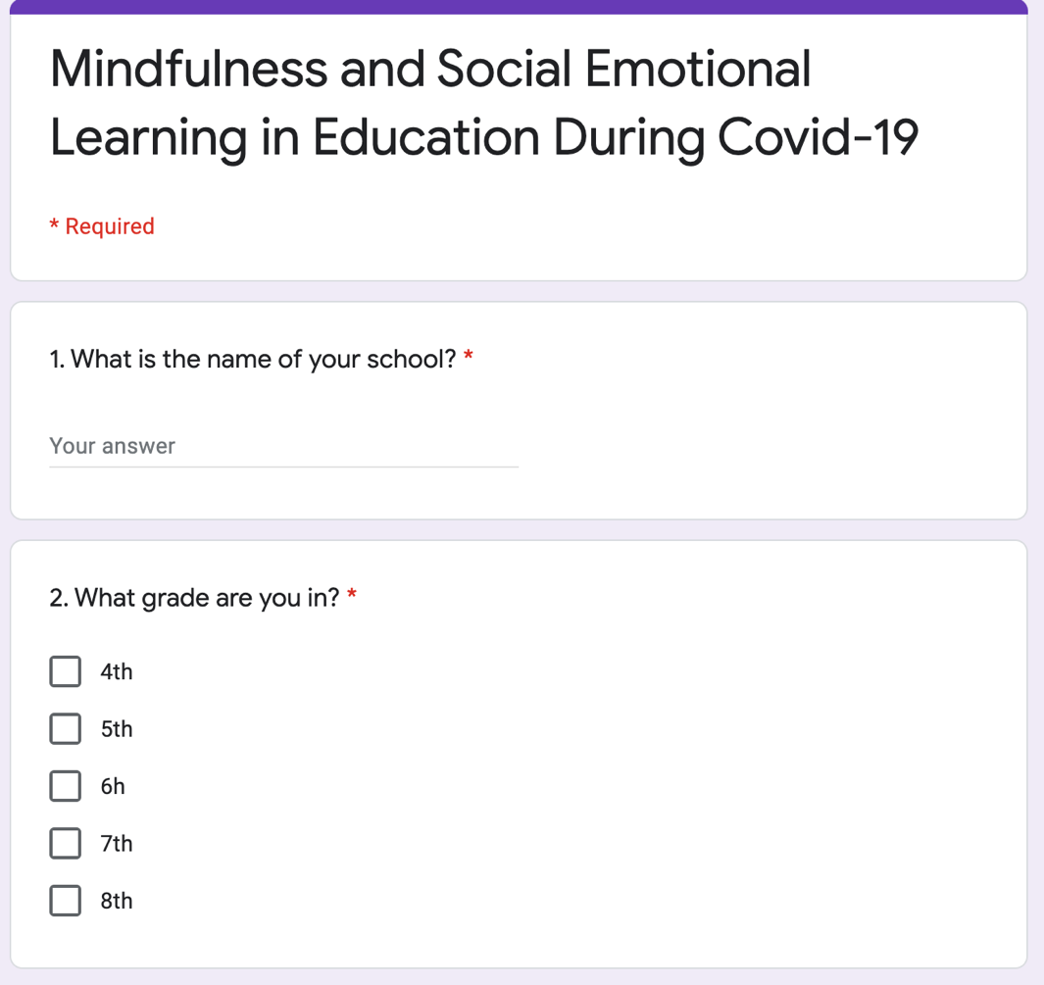Survey

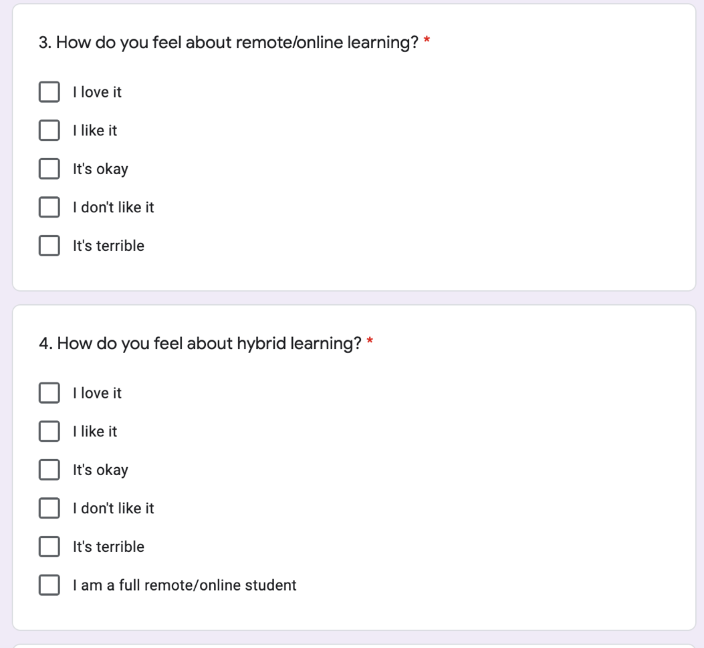

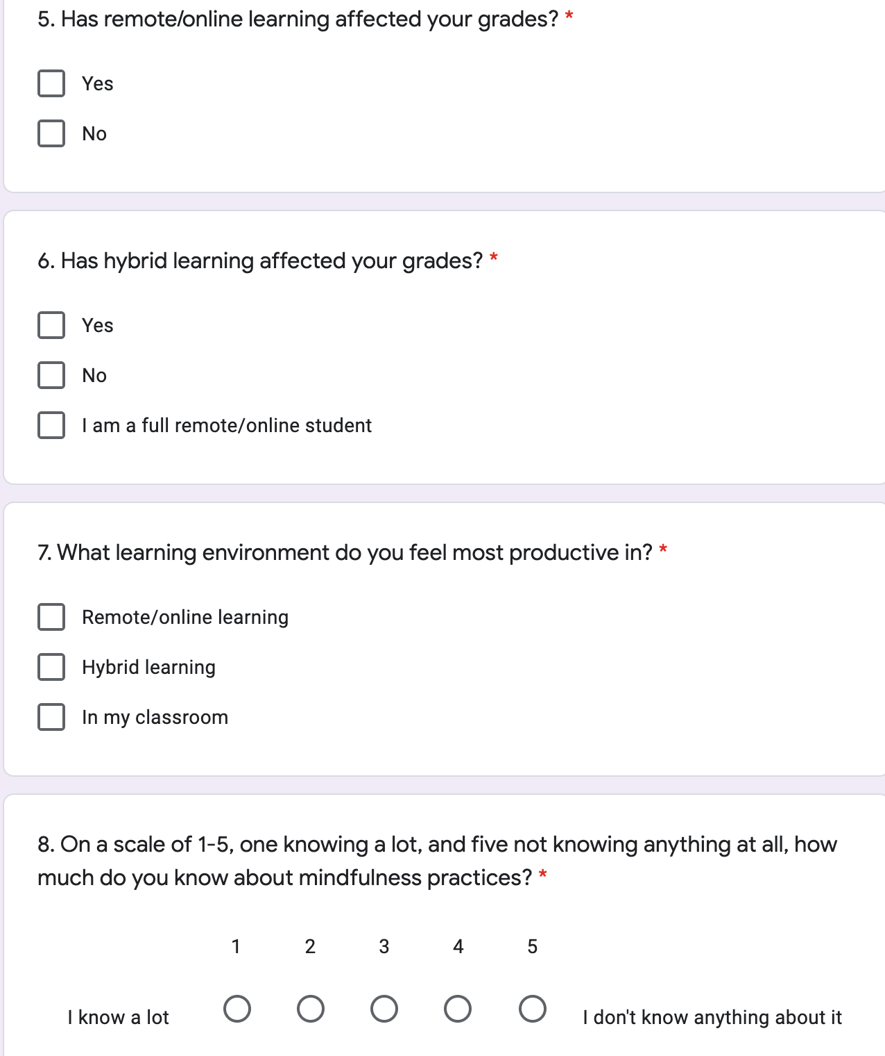

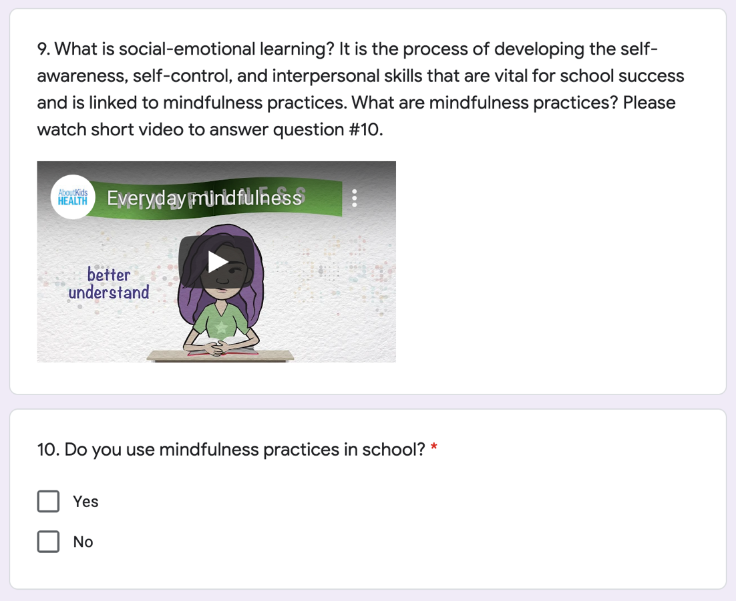

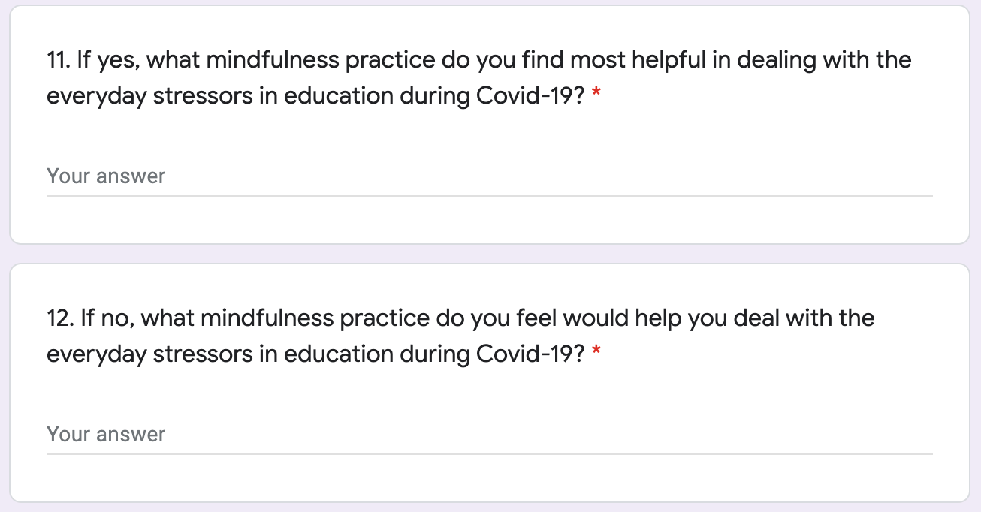

[Link to Mindfulness Survey](https://docs.google.com/forms/d/e/1FAIpQLSfJY3yR4GskL0tBAKLbKCGKvcrDsGu7Kg6rIyLPwUo1S5J0Wg/viewform?usp=pp_url)