**Assessment 2-Hiring Three Technology Coordinators**

Deniz Ismailoff

New Jersey City University

EDTC 815: Adv. Adm. & Super Tech. Edu. Setting

Dr. Tracy Amerman

November 1, 2021

**Educational Technology Coordinator Job Requirements**

An Educational Technology Coordinator performs a range of comprehensive duties. Its

An Educational Technology Coordinator performs a range of comprehensive duties. Its responsibility can be inferred as working with various technology infrastructures within a school, district, or organization. Specific duties of an educational technology coordinator include assisting end-users experiencing difficulties, installing and fixing computer systems, telecommunications, and coordinating technology plans. In addition to these technical abilities, successful educational technology coordinators require interpersonal and practical problem-solving skills and strong leadership abilities (Frazier & Hearrington, 2017). These skills are essential for the position because schools require Educational Technology Coordinators to oversee the addition of technology to curricula. They must plan, coordinate, and direct activities and programs related to curriculum development, instruction, assessment, and instructional software that supports the practical use of instructional technology.

The Educational Technology Coordinator also acquires and updates the skills necessary to run effective professional development and is responsible for training, modeling, and assisting teachers in integrating technology in the classroom to improve student achievement and ensure that every learner meets and exceeds the New Jersey State Learning Standards (NJSLS). They should also be knowledgeable in The International Society for Technology in Education (ISTE), which has developed The National Educational Technology Standards (NETS). These standards are essential for learning, teaching, and leading in the digital age and are widely recognized and adopted worldwide (ISTE, 2021).

Three Educational Technology Coordinators' job requirements and salaries were analyzed in neighboring school districts in Passaic County, Northern New Jersey. Table 1 displays the evaluation of the three school districts' Educational Technology Coordinators' requirements and salaries.

***Table 1. Passaic, Clifton, and Paterson Public Schools’ Educational Technology Coordinator Requirements and Salary***

|  |  |
| --- | --- |
| **Educational Technology Coordinator** | |
| **School District** | **Requirements and Salary** |
| Passaic Public Schools | * Bachelor’s degree in educational technology or education * Complete a school-based internship * Licensed educational/instructional technology and/get an endorsement * Strong problem-solving, research, and planning, and coding skills * Average annual salary: $61,101   (Passaic Public Schools, n.d.). |
| Clifton Public Schools | * Bachelor’s, Master’s, specialist, or doctoral degree in educational technology * Licensed educational/instructional technology * Strong programming, coding, and communication skills * Average annual salary: $61,934   (Clifton Public Schools, n.d.). |
| Paterson Public Schools | * Master’s, specialist, or doctoral degree in educational technology, instructional technology * Licensed educational/instructional technology * Prior teaching experience * Experienced educational technology specialist * Experienced with state testing * Programming and coding experience * Average annual salary: $70,148   (Paterson Public Schools, n.d.). |

**Similarities and Differences**

The main similarity in job requirements of Educational Technology Coordinators in the three specified school districts in Passaic County requires either a license and/or degree in educational/instructional technology. Some experience is also preferred by each school district but not required. Strong coding or programming skills were also mentioned as a factor in hiring for this position. This consistency is essential in supporting the needs of educators as the Educational Technology Coordinator assists and supports the creation of technology-infused lessons and the implementation of New Jersey Student Learning Standards (NJSLS) for each grade level.

By contrast, the salary for Educational Technology Coordinators in the three districts in Passaic County varied. Paterson was rated the number one out of ten for the top paying salaries for Educational Technology Coordinators in New Jersey, with an average annual salary of $70,148. Clifton Public Schools was rated number five out of ten for the top paying salary in New Jersey, with an average annual salary of $61,934. Lastly, Passaic Public Schools was rated number seven out of the ten top-paying salaries in New Jersey with an average annual salary of $61,101. The possibility of a lower cost of living may help determine the balance between location and salary for an Educational Technology Coordinator position.

**Introduction to the School District**

The urban school district searching for three Educational Technology Coordinators is located in Passaic County, New Jersey. The district has 15 elementary schools that house pre-kindergarten through fifth-grade students. There are two middle schools with sixth through eighth grade and one high school with ninth through twelfth-grade students. The hired Educational Technology Coordinators will work collaboratively under the leadership of the District Superintendent and Director of Educational Technology Services. The three Educational Technology Coordinators will be divided into elementary, middle, and high school levels. Each contract is a 12-month, tenure-track position, and the wage depends on the approved district salary guidelines, which are increased with additional experience, qualifications, and credentials.

**Elementary School Educational Technology Coordinator**

Position Title: Elementary School Educational Technology Coordinator (PreK-5)

Reports To: Director of Educational Technology, Superintendent of Schools, Assistant Superintendent of Curriculum and Instruction

Coordinates With: School Administrators, Instructional Supervisors, Support Personnel

Supervises: PreK-5 Teachers, Students

Description: The Elementary School Educational Technology Coordinator will help integrate current and emergent instructional technologies into school-based instructional programs to enhance and enrich student learning and skill acquisition/mastery.

Job Responsibilities: The indicated responsibilities are intended as an illustration of the various types of work performed. The omission of specific duties does not exclude them from the position if the work is similar, related, or a logical assignment to the position.

* Collaborate with educators to meaningfully and effectively integrate technology into teaching; this includes lesson design, curriculum development, pedagogy mentorship, and classroom co-teaching
* Provide teacher leadership, coaching/mentoring, learning and technology integration
* Work with curriculum staff to develop and implement technology-enhanced curriculum integration projects
* Design, facilitate, and lead professional learning experiences in educational technology
* Model effective classroom management and collaborative learning strategies to maximize teacher and student use of digital tools and resources
* Research technology-based instructional strategies and emergent skills, tools, and resources, and disseminate to staff as appropriate
* Coach teachers in, and models use of, online and blended learning, digital content, and collaborative learning networks
* Meet with school administrators and content supervisors at the school(s) of assignment or central office level to coordinate services and resources
* Participate in professional organizations related to education and technology
* Assist administrators and content supervisors with data-driven decision making relating to all areas of curriculum and instruction
* Review and evaluates technology software and assess proposals involving technology for impact on student learning
* Support the analysis, design, development, implementation, and evaluation of school initiatives involving educational technology
* Assist in recommending and managing instructional technology purchasing, acquisition, and distribution; manages any budgeting/purchasing authority delegated by the principal
* Conduct personal professional learning including research relating to professional growth goals, related conference attendance, and workshops
* Support the School Testing Coordinator's technology-related needs for state testing
* Perform related duties, as required or assigned
* Create the school’s annual technology budget

Terms of Employment: Twelve-month contract

Evaluation: The Educational Technology Coordinator will be evaluated utilizing the five basic domains of the field. These domains include design, development, utilization, management, and evaluation. The terms refer to both areas of the knowledge base and to functions performed in the field. Each domain of Educational Technology includes a body of knowledge based on both research and experience. Walkthroughs from school administration will also be conducted throughout the year for check-ins and progress monitoring.

Qualifications:

* A bachelor's degree in instructional technology, education or any other field providing a strong foundation for success in the essential functions of this class and level of work, or an equivalent combination of education, experience and training is required
* Two years of progressively responsible experience (a) training teachers or other adults in the integration of technology for instruction and productivity using the modes of modeling, one-on-one, small group and large groups, (b) delivering and integrating technology in instructional programs for pre-K through fifth grade students, or (c) assessing and evaluating software and media based on curriculum, learning styles and instructional methodologies are required
* A master's degree providing a strong foundation for success in the essential functions of this class may be substituted for both years of these two years of experience on a year-for-year basis
* License/Certification- A postgraduate professional license or a collegial professional license issued by the New Jersey Board of Education is required.

**Middle School Educational Technology Coordinator**

Position Title: Middle School Educational Technology Coordinator (6-8)

Reports To: Director of Educational Technology, School Administration

Coordinates With: Instructional Curriculum Supervisors, School Administration, other IT’s

Supervises: 6-8 Teachers, Students

Description: The Middle School Educational Technology Coordinator is responsible for training, modeling, and assisting teachers in integrating technology in the classroom to improve student achievement and ensure that every student meets and exceeds the standards. The Educational Technology Coordinator acquires and updates skills as necessary for effectively training users in applications on the network, and coordinates activities of outside vendors, consultants, and trainers.

Job Responsibilities: The Educational Technology Coordinator implements, coordinates, and evaluates the integration of educational technology as tools to support instruction. In addition, the Educational Technology Coordinator performs the following duties:

* Teach and implement a sequential program of study, following school directives, for teaching students the use of computers and educational technology, information retrieval and research, manipulation of data, visual and audio presentation, and coding
* Provide primary support for educational technology and integrated learning systems for the school’s curriculum
* Deliver training for all educational technology including wireless tablet devices, Chromebooks, and a variety of other educational software and devices
* Participate in the development of curricular standards and benchmarks to encourage appropriate use of educational technology
* Work with educators to develop lesson plans and activities involving use of technology to further attainment of educational goals
* Inform teachers of new technologies or software which may assist in developing concepts of content specific materials
* Assist with the general maintenance of all school and network workstations and printers
* Support with the daily software and hardware troubleshooting of all school technological equipment
* Work with school administration and other IT personnel, to develop and implement the school’s technology plan
* Establish evaluation guidelines so that data can be evaluated and utilized as a part of the evaluation of district progress
* Work with administration and faculty to write grants for implementation of technology related educational programs
* Identify technology-oriented leaders in each academic discipline, who can assist in decision-making processes and assist faculty in simple technical or curricular concerns related to technology
* Develop contacts with vendors who are willing to provide loans of hardware and software, or assist in training educators in educational technology
* Develop contacts with other educational institutions to encourage dissemination of effective policies and ideas for use of technology in the educational process.
* Create, implement, and periodically evaluate a school technology oriented in-service plan
* Help the school to develop and implement plans for the acquisition and maintenance of hardware and software
* Disseminate technology-related information within the school via news bulletins, electronic main (database), presentations at district and building level staff meetings, etc.
* Pursue professional growth in the field of educational technology
* Create the annual technology budget

Terms of Employment: Twelve-month contract. Salary will be commensurate with experience and past results. Employee benefits include medical, dental, and participation in state pension program.

Evaluation: The Educational Technology Coordinators will be evaluated annually by the Superintendent and three times a year by the school administration. The evaluation model utilized will be The Danielson Framework and The Educational Technology Framework: PICRAT Model.

Skills and Qualifications:

* Hold a bachelor’s degree, preferably in Computer Science, Educational Technology, or a related technology/computer field from an accredited college or university
* Hold a New Jersey Educational Services certification with an endorsement as an Educational Media Specialist as provided by N.J.A.C. 6:11-11.17, or a certificate from reciprocal state is preferred
* Have at least three years’ experience in working with students and educational staff in the field of educational technology, experienced in an urban school setting is preferred
* Knowledge of existing network management tools and emerging tools, architectural concepts and principles
* Articulate and communicate complex technology concepts effectively in non-technical terms in a compelling manner
* Analyze complex business/technical problems to define system scope and objectives
* Demonstrate the ability to utilize electronic equipment for word processing, data management information retrieval, visual and audio presentations, and telecommunications
* Assist teachers and administrators to integrate educational technology into the curriculum and the instructional programs in support of student achievement
* Demonstrate knowledge and understanding of instructional programs, curriculum development and program evaluation, child growth and development, effective instructional strategies, classroom management, learning assessment and diagnosis, and research related to learning, particularly utilizing technology
* Demonstrate achievement in utilizing advanced technology applications
* Willingness to offer and respond positively to feedback; Commitment to daily personal and professional growth
* Demonstrate capacity in being a facilitator for change, well organized, and collaborative
* Exhibit a personality that demonstrates enthusiasm and interpersonal skills to relate well with students, staff, administration, parents, and the community

**High School Educational Technology Coordinator**

Position Title: High School Educational Technology Coordinator (9-12)

Reports To: Director of Educational Technology, Superintendent of Schools, Supervisor of Curriculum and Instruction, School Administration

Coordinates With: School Principal, Instructional Supervisors, Academic Coaches, other IT’s

Supervises: 9-12 Teachers, Students

Description: The High School Technology Coordinator will work in in all relevant facets of the school/organizational/IT/educational technology department. The applicant will work with students of middle/high school age and must have experience in educational technology. The educational technology coordinator will work on campus with a mix of old and new buildings/infrastructures, and is able to balance the role of educational technology in a school that values discussion and relational learning.

Job Responsibilities:

* Support teachers with STEM Academy in developing authentic experiences for high school students enrolled in the program
* Hold a BA/BS, teaching certificate, and must have knowledge and experience in educational technology
* Manage, install, and oversee campus network, servers, computers, telephone systems, backups, emergency notification system, and cloud infrastructure
* Run, install, oversee, and manage other educational technology equipment: projectors, Apple TV, audio systems, telephones, and printers
* Oversee the technology budget and educational technology allowances for teachers
* Collaborate with outside vendors: Comcast, National Grid, Google, and other companies to maintain all educational technology systems and subscriptions on campus
* Serve as a liaison with vendors for warranty repairs and software
* Oversee student and faculty email and computer accounts, G Suite, Google Classroom, LDAP, MDM, etc.
* Assist faculty on technology issues that arise: Student evaluations, logins, Google Classroom, etc.
* Provide hardware and software support for Mac, Windows, and Chrome OS and a wide variety of software applications
* Work with other IT’s to update handbook policies and procedures in educational technology
* Provide and ensure success of educational technology professional developments for faculty
* Attend IT conferences and webinars as appropriate for student information systems and platforms/databases
* Attend weekly faculty meetings, administrative team meetings, and assist with educational technology for other meetings as appropriate
* Effective written and verbal communication skills
* Strong analytical, organizational, process, and problem-solving skills
* Ability to support a diverse population of faculty, staff, and students with varying levels of technical knowledge
* Ability to lift and move equipment up to 50 pounds, climb ladders and install overhead items, and perform work in a prone or crouching position
* Evaluate and recommend new technologies for the staff
* Managing the 1:1 Chromebook initiative at the high school level
* Experience or proficiency with the following preferred: Enterprise WIFI (Ubiquiti Unifi platform) G Suite for Education (especially Google Classroom, Chrome device management), SonicWall firewall (UTM), Connect VoIP platform, Synology backup, Apple AirPlay, and Windows 10

Terms of Employment: Twelve-month contract. Salary is commensurate with experience. Comprehensive benefits package included, including retirement plan with match, health, dental, vision and life insurance.

Evaluation: The Educational Technology Coordinators will be evaluated annually by the Superintendent and three times a year by the school administration. Informal walkthroughs will also be conducted. The evaluation model that will be utilized is The Danielson Framework and TPACK framework.

Qualifications:

* Hold a bachelor’s degree in education is required
* A master’s degree in information technology or educational technology is preferred.
* New Jersey standard teaching certification is required, preferably certification in a content area from kindergarten through twelfth grade
* Three to five years of experience integrating instructional technology into the classroom
* Expertise in high school education and curriculum, specifically curriculum design
* Extensive knowledge of technological hardware and software, including the ability to troubleshoot

**Similarities and Differences of the Educational Technology Coordinator Positions**

The main similarity in job requirements of the potential Educational Technology Coordinator Candidates is the required licensing and/or degree in the field. Each position has an evaluation process. The job descriptions are parallel since the elementary, middle, and high school Educational Technology Coordinator positions are within the same district. The candidates will have the responsibility of instructional work and some troubleshooting in their respective school buildings. Each position requires collaboration and professional development with staff, administration, and other IT's. Lastly, each Educational Technology Coordinator will create and/or assist with its technology budget for the following fiscal school year. This consistency is essential in supporting the needs of educators as the Educational Technology Coordinator assists and supports the creation of technology-infused lessons and the implementation of New Jersey Student Learning Standards (NJSLS) for every grade level.

By contrast, the educational technology needs vary based on students’ grade levels. While elementary students focus more on utilizing child-friendly educational applications, middle and high school students utilize standard-based educational platforms for rigorous lessons and formative and summative assessments. The compiled student data helps educators differentiate their lessons to meet the needs of their learners. This helps with tailored instruction for rigorous learning, a higher probability for achievement, and increased academic proficiency scores.

**Policies, Procedures Manual, and Necessary Forms**

**Observations and Evaluations**

The school district hiring for the elementary, middle, and high school Educational Technology Coordinator position utilizes informal and formal observations. Walkthroughs are conducted for informal observations in all three schools. In addition, the Educational Technology Coordinators are evaluated utilizing the (ISTE) Education Leader Standards. The domains within these standards include Equity and Citizenship, Advocate, Visionary Planner, Empowering Leader, Systems Designer, and Connected Learner. For evaluation, Charlotte Danielson Framework for Teaching is utilized in two out of the three schools (middle and high school). Although the Educational Technology Coordinator is not responsible for conducting formal observations for educators, technology integration is essential for 21st-century learners. The Danielson framework is utilized to assess Planning and Preparation-Domain 1, The Classroom Environment-Domain 2, Instruction-Domain 3, and Professional Responsibilities-Domain 4. The observers provide specific feedback, which is documented on the schools’ database under the evaluation tab. Charlotte Danielson’s framework can be found in Appendix A.

The Educational Technology Framework: PICRAT Model is also utilized in middle school. The PICRAT Model for the middle school Educational Technology Department provides ongoing support and training for educators. The PICRAT Model is an extension of the RAT framework. RAT is an acronym for replacing, amplifying, and transforming. The model holds that when technology is utilized in a classroom setting, it is either utilized to replace traditional teaching, amplify the learning, or transform learning in ways that were not feasible without technology (Kimmons et al., 2020). With this model, a teacher can ask the two guiding questions of any technology use and place each lesson, activity, or instructional practice into one of the nine units. The PICRAT Model can be found in Appendix B.

Lastly, the TPACK framework is utilized by Educational Technology Coordinators in the high school. The TPACK framework, developed by Mishra and Koehler (2006), is a self-assessment rubric centering on the idea that content and pedagogy are the basis for technology integration to enhance students learning. The technological (T), pedagogical (P), content (C), technological pedagogical (TP), technological content (TC), pedagogical content (PC), and technological pedagogical content knowledge (TPACK) are evaluated by the educator (Harris et al., 2010). The Educational Technology Coordinators utilize the framework to guide instruction with the notion of technology in mind. The TPACK framework can be found in Appendix C. The TPACK technology integration rubric can be found in Appendix D.

References

Clifton Public Schools. (n.d.). *Employment*. <https://www.clifton.k12.nj.us/domain/67>.

Danielson, C. (2009). *Implementing the framework for teaching in enhancing professional*

*learning* (2nd ed.)*.* ASCD.

Frazier, M., & Hearrington, D. (2017). The technology coordinator’s handbook (3rd ed.). ISTE.

Harris, J., Grandengett, N., & Hofer, M. (2010). Testing a TPACK-based technology integration

assessment rubric. *Society for Information Technology & Teachers Education*

*International Conference* (pp. 3833-3840). Association for the Advancement of

Computing in Education.

International Society for Technology in Education (ISTE). (2021). Retrieved from: <https://www.iste.org/standards/iste-standards-for-teachers>.

IT Domains. (n.d.). *Department of curriculum, leadership, and technology.* Retrieved from: <https://www.valdosta.edu/colleges/education/ltwd/documents/Domains_Document.pdf>.

Kimmons, R. Graham, C., R., & West, R. E. (2020). The PICRAT model for technology integration in teacher preparation. Contemporary Issues in Technology and Teacher Education (CITE Journal). Retrieved from: <https://citejournal.org/volume-20/issue-1-20/general/the-picrat-model-for-technology-integration-in-teacher-preparation/>.

Mishra, P., & Koehler, M. J. (2006). Technological pedagogical content knowledge: A new framework for teacher knowledge. *Teachers College Record, 108*(6), 1017-1054.

New Jersey Department of Education. (n.d.). *Individual professional development planning and implementation.* <http://nj.gov/education/profdev/pdp/ipdp/>.

Passaic Public Schools. (n.d.). *Employment*. Retrieved from <https://passaicschools.org/employment-opportunities/>.

Paterson Public Schools. (n.d.). *Employment*. Retrieved from: <https://www.paterson.k12.nj.us./>.

The Danielson Group. (2011). Charlotte Danielson’s framework for teaching evaluation instrument. Retrieved from: <https://www.k12.wa.us/sites/default/files/public/tpep/frameworks/danielson/danielson-framework-for-teaching-evaluation-instrument-2011.pdf>.

The National Educational Technology Standards (NETS). (2021). Retrieved from: <http://technologiesforteaching.weebly.com/uploads/1/6/3/3/16335480/nets-t-standards.pdf>.

ZipRecruiter. (2021, October 26). School technology coordinators salary in New Jersey. Retrieved from: <https://www.ziprecruiter.com/Salaries/Educational-Technology-Coordinator-Salary--in-New-Jersey>.

Appendix A

Charlotte Danielson’s Evaluation Instrument

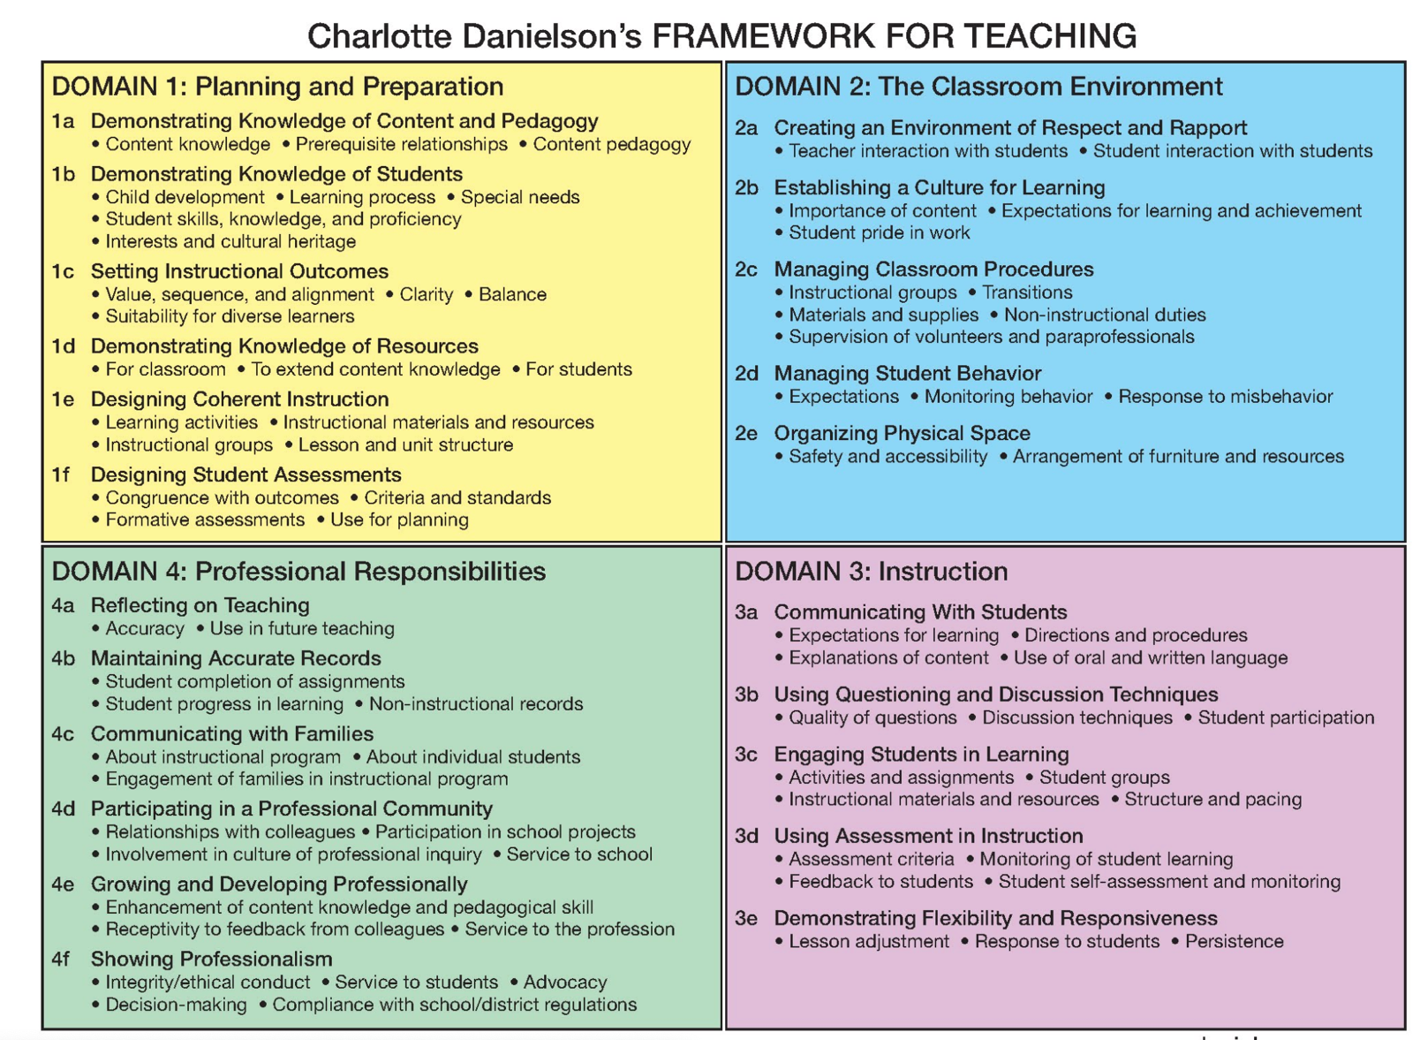

The Danielson Group. (2011). Charlotte Danielson’s framework for teaching evaluation instrument. Retrieved from: <https://www.k12.wa.us/sites/default/files/public/tpep/frameworks/danielson/danielson-framework-for-teaching-evaluation-instrument-2011.pdf>.

The Danielson Group. (2011). Charlotte Danielson’s framework for teaching evaluation instrument. Retrieved from: <https://www.k12.wa.us/sites/default/files/public/tpep/frameworks/danielson/danielson-framework-for-teaching-evaluation-instrument-2011.pdf>.

Appendix B

The PICRAT Model for Technology Integration

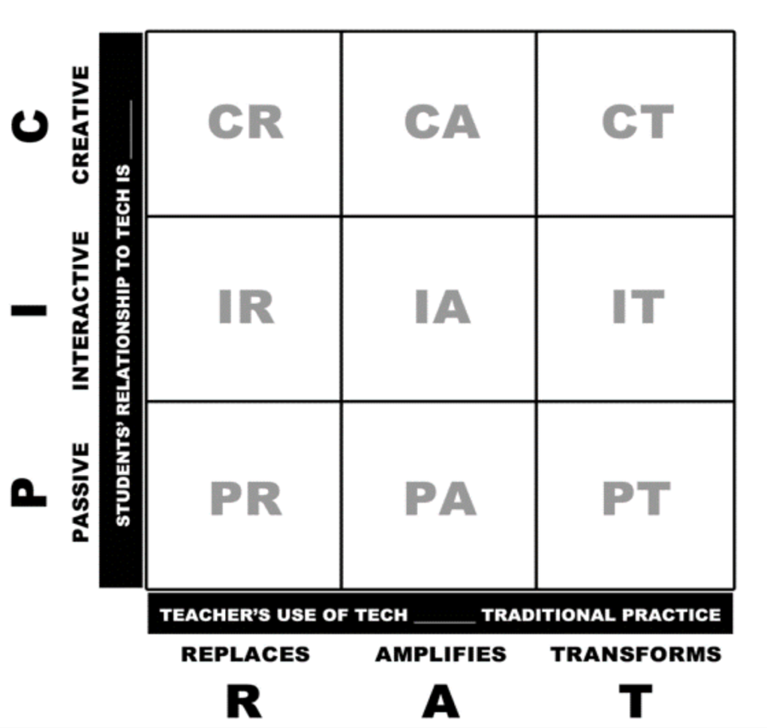

Kimmons, R. Graham, C., R., & West, R. E. (2020). The PICRAT model for technology integration in teacher preparation. Contemporary Issues in Technology and Teacher Education (CITE Journal). Retrieved from: <https://citejournal.org/volume-20/issue-1-20/general/the-picrat-model-for-technology-integration-in-teacher-preparation/>.

Appendix C

Technological Pedagogical Content Knowledge (TPACK) Diagram

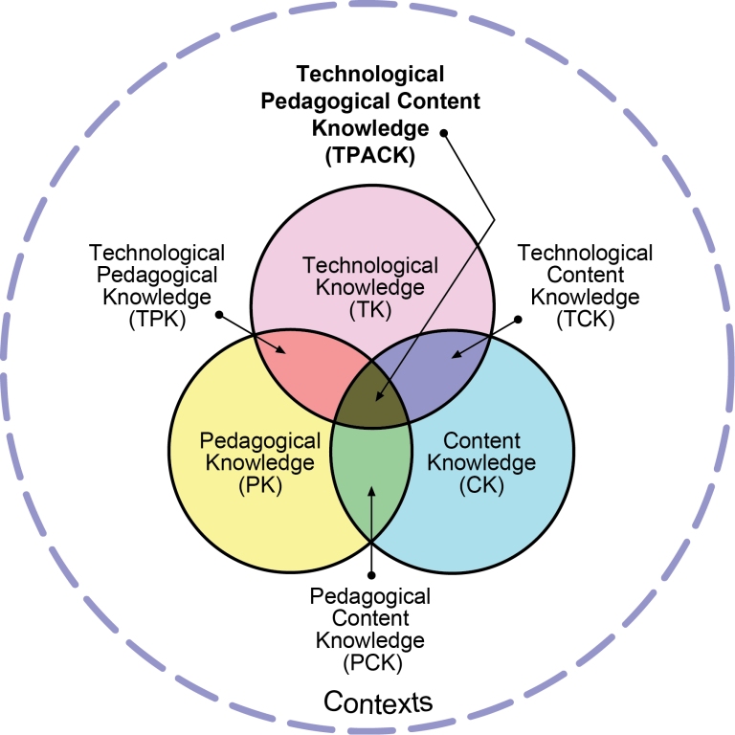

Reproduced by permission of the publisher, © 2012 by tpack.org

Developed by Matthew Koehler and Punya Mishra

Appendix D

Technological Pedagogical Content Knowledge (TPACK) Technology Integration Rubric

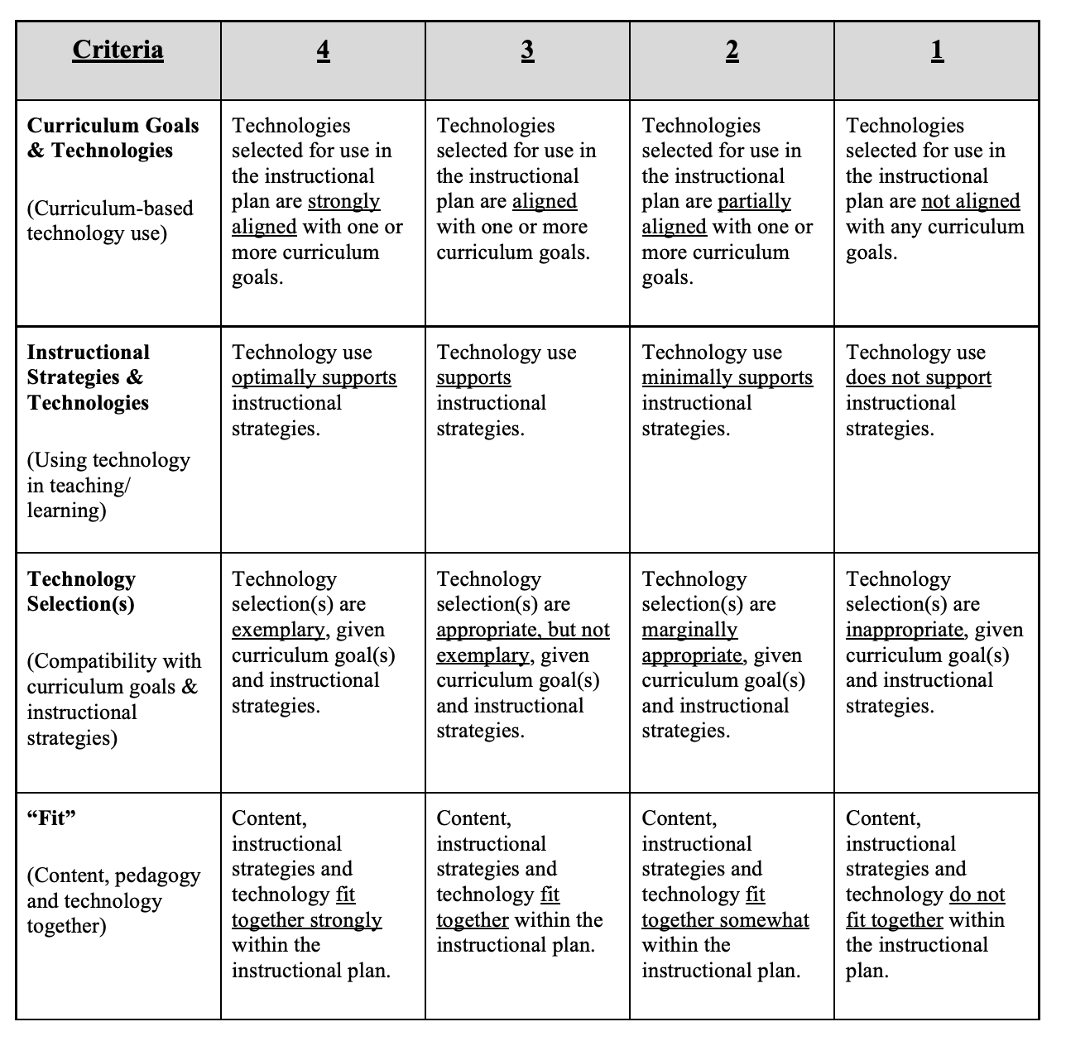

Harris, J., Grandgenett, N., & Hofer, M. (2010). Testing a TPACK-based technology integration assessment instrument. In C. D. Maddux, D. Gibson, & B. Dodge (Eds.). Research highlights in technology and teacher education 2010 (pp. 323-331). *Society for Information Technology and Teacher Education (SITE).*